2160
SPRAY DIFFUSERS
Torna all'elenco
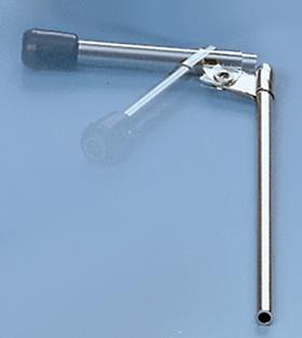
Spray diffusers, with plastic mouthpiece, finely made in nickelplated brass.

