2110..53
DOUPLE DIPPERS
Torna all'elenco
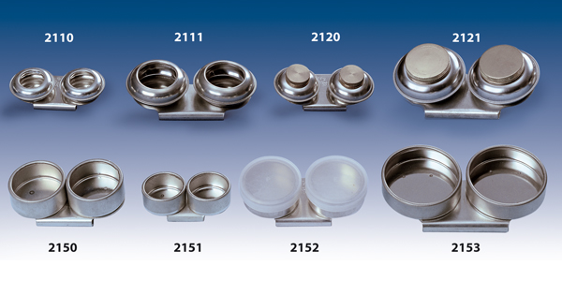

 | PRODUCTS
art. 2110 | Double metal dippers Ø 40 mm
art. 2111 | Double stainless dippers Ø 55 mm
art. 2120 | Double metal dippers Ø 40 mm. with screw top
art. 2121 | Double stainless dippers Ø 55 mm. with screw top
art. 2150 | Double metal dippers Ø 40 mm
art. 2151 | Double metal dippers Ø 31 mm
art. 2152 | Double metal dippers Ø 40 mm. with plastic top
art. 2153 | Double metal dippers Ø 55 mm

