Top of Form

434
Pale Lemon

346
Lemon Yellow
114
Cadmium Yellow Pale Hue

653
Transparent Yellow
120
Cadmium Yellow Medium Hue

116
Cadmium Yellow Medium

115
Cadmium Yellow Deep Hue

090
Cadmium Orange Hue

682
Vermilion Hue

099
Cadmium Red Medium

095
Cadmium Red Hue

203
Crimson

466
Permanent Alizarin Crimson

502
Permanent Rose

448
Opera Rose

488
Permanent Magenta
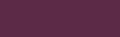
075
Burgundy

444
Pale Violet

728
Winsor Violet

660
Ultramarine

446
Powder Blue

179
Cobalt Blue Hue

178
Cobalt Blue

706
Winsor Blue

541
Prussian Blue Hue

138
Cerulean Blue Hue

435
Pale Olive

599
Sap Green

447
Olive Green

311
Hookers' Green

483
Permanent Green Light

484
Permanent Green Middle

482
Permanent Green Deep

522
Phthalo Green

232
Deep Turquoise
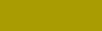
294
Green Gold
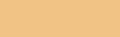
060
Buff Titanium

422
Naples Yellow
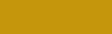
744
Yellow Ochre
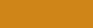
553
Raw Sienna Opaque
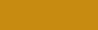
552
Raw Sienna
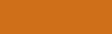
074
Burnt Sienna

077
Burnt Sienna Opaque

437
Pale Terracotta
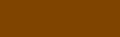
076
Burnt Umber
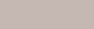
438
Pale Umber
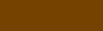
554
Raw Umber
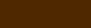
676
Vandyke Brown

465
Paynes Gray
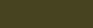
331
Ivory Black

337
Lamp Black
386
Mars Black
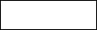
415
Mixing White
644
Titanium White
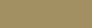
283
Gold

214
Copper

617
Silver

537
Process Yellow

533
Process Magenta
535
Process Cyan

